

**USER GUIDE**

**for Car Management Application**

**Version 1.0**

**Made by Group 1**

1. **Install Application:**

Click on **“setup.exe”**

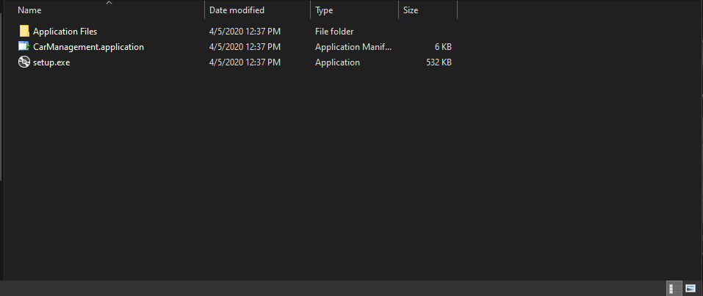

Then click **Install**

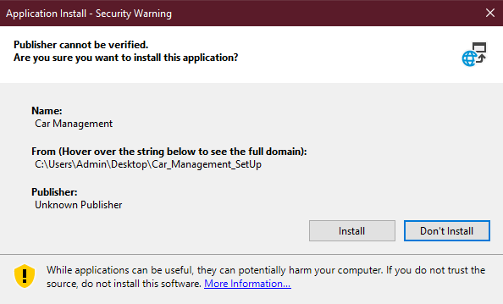

1. **Use Program:**

Open the program

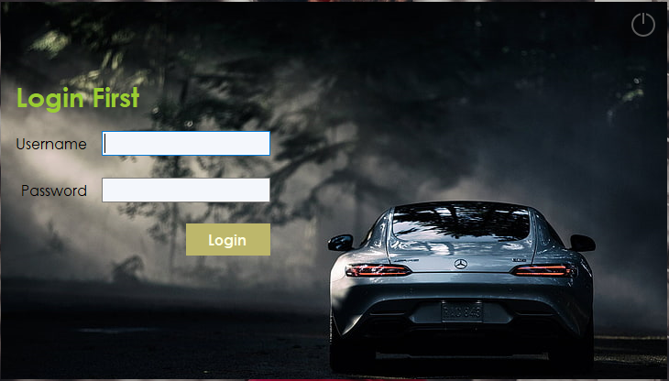

Type valid username and password to continue

GUI after login with full option:

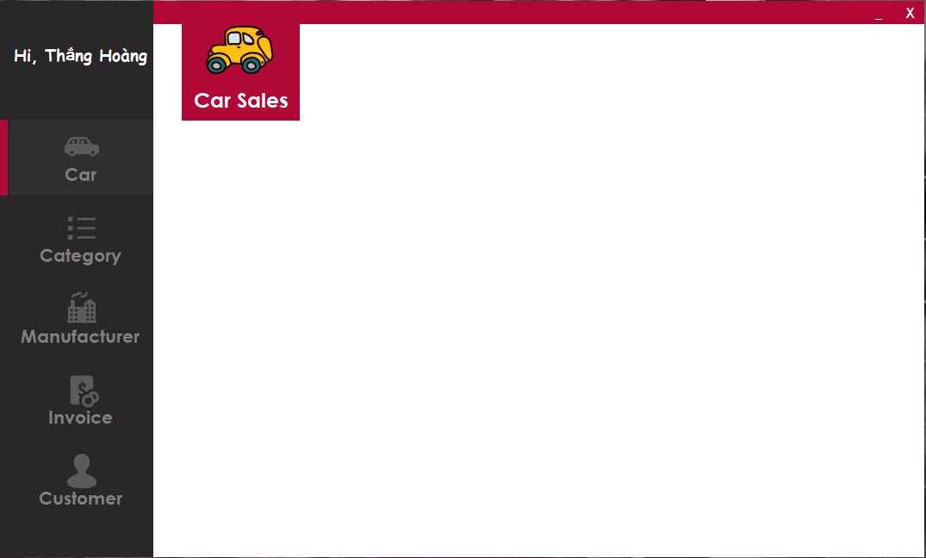

Click to any item on menu and left bar to view section you want

Example: Click on Car button -> Show list of car

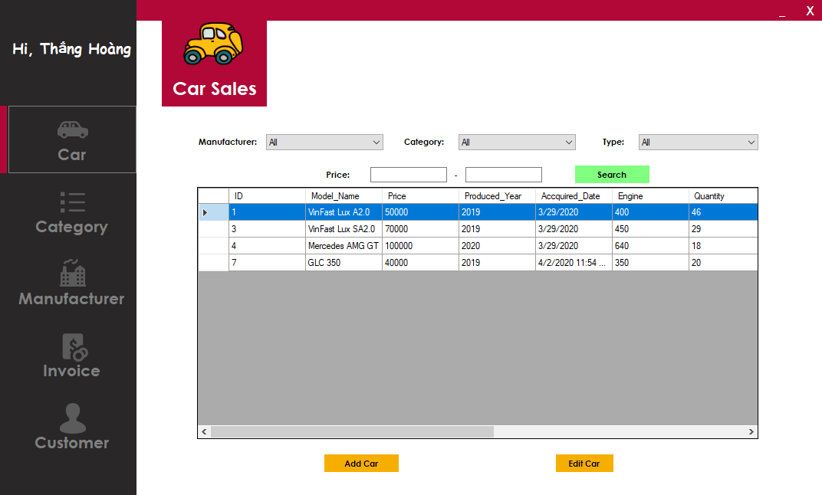

Click **Add Car** to add new Car -> Fill in the form info -> **Save** to add data to system, **Cancel** to cancel add new Car.

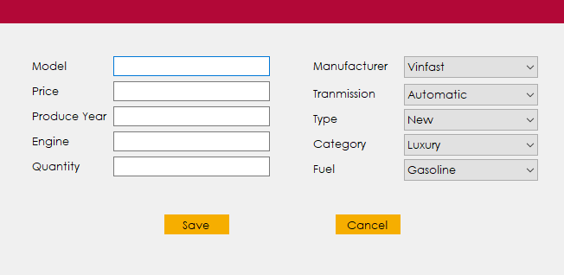

Click **Edit Car** to Edit Car -> Fill in the form info -> **Save** to update data to system, **Cancel** to cancel Edit Car.

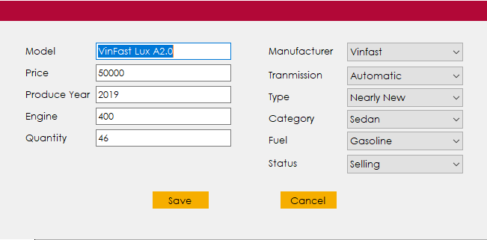

Do the same with **Category**, **Manufacturer**, **Invoice**, **Customer** section. In addition, you can view a list of Customers which can’t be added/edited.

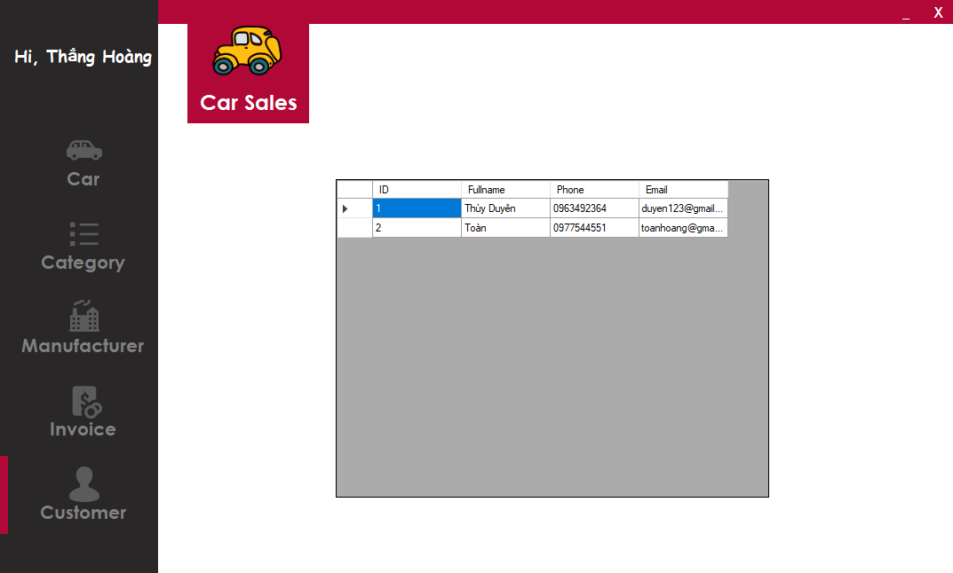

In **Invoice**, you can view list Invoice and can create invoice, and **can view revenue reports under the supervisor role.**

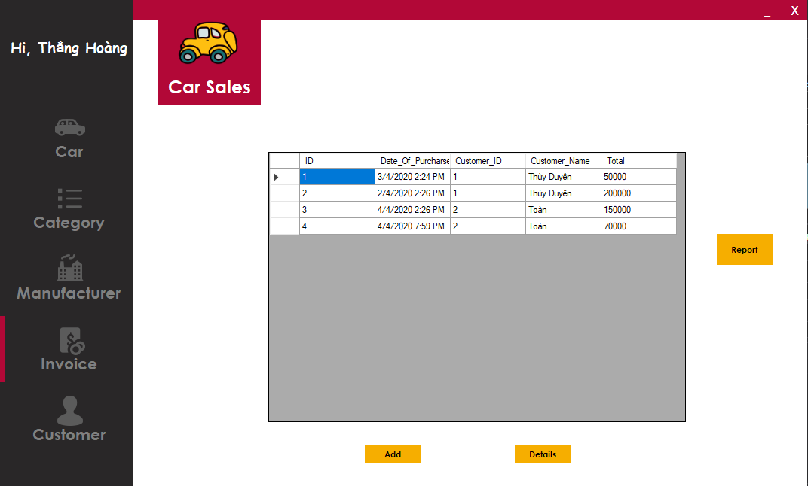

Click **Add** to add Invoice -> Fill in the form info -> **Save** to add data to system, **Cancel** to cancel add new Invoice.

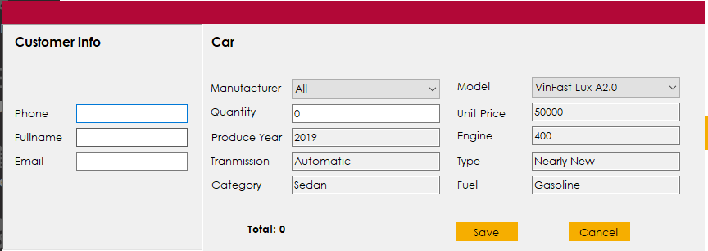

By clicking **Report**, you can see profit per year of company under graphs

Enter year you want to see, example 2020

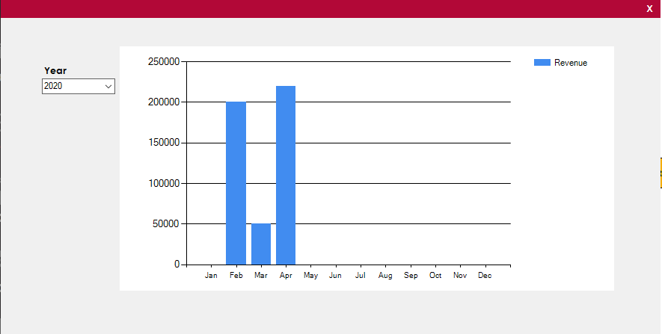

Finally, you can exit the program by clicking the **Exit button** in the top right of the home screen.



**Enjoy the Car Management Application!**